**IAM TASK**

1. **Create one IAM user and assign ec2,s3 full access role.**

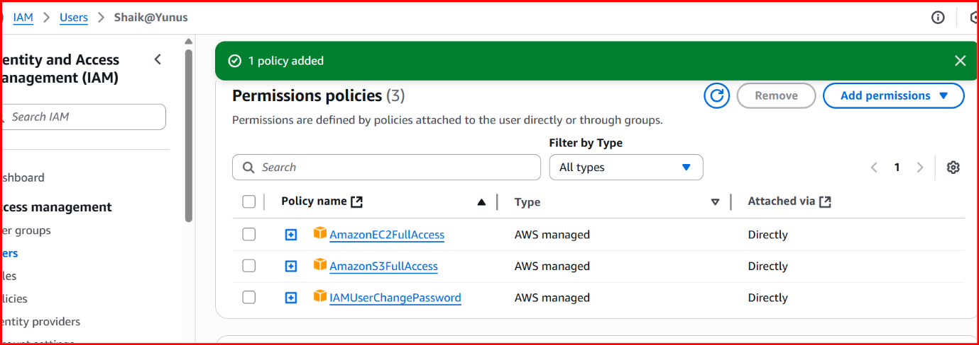

**Created s3 bucket in IAM user**

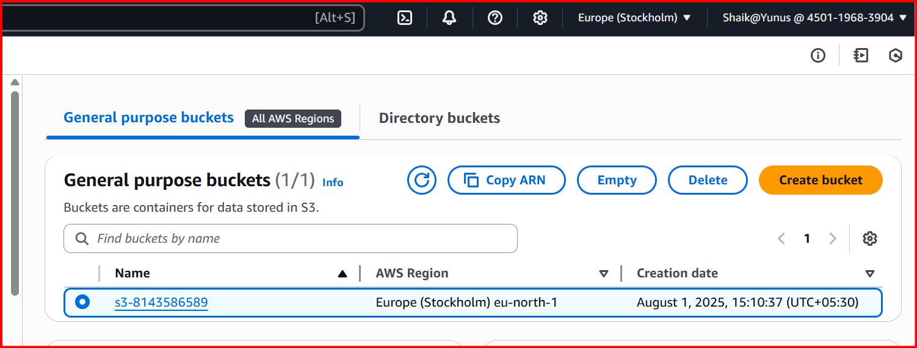

**Before giving access**

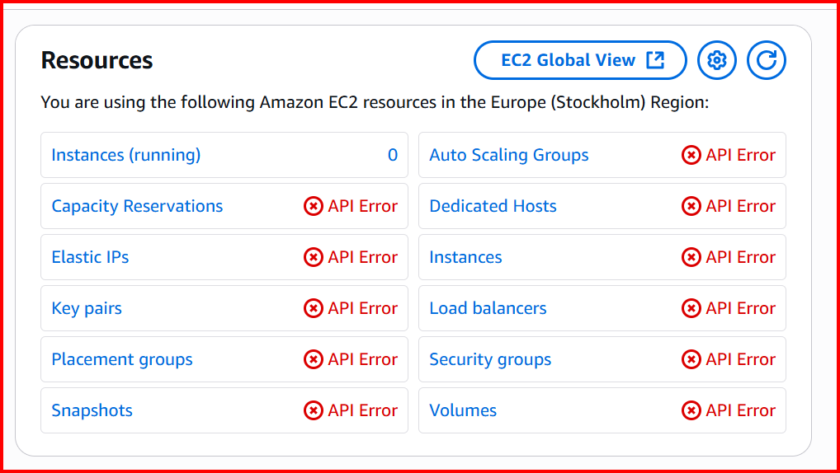

**After giving full access Instance has been created.**

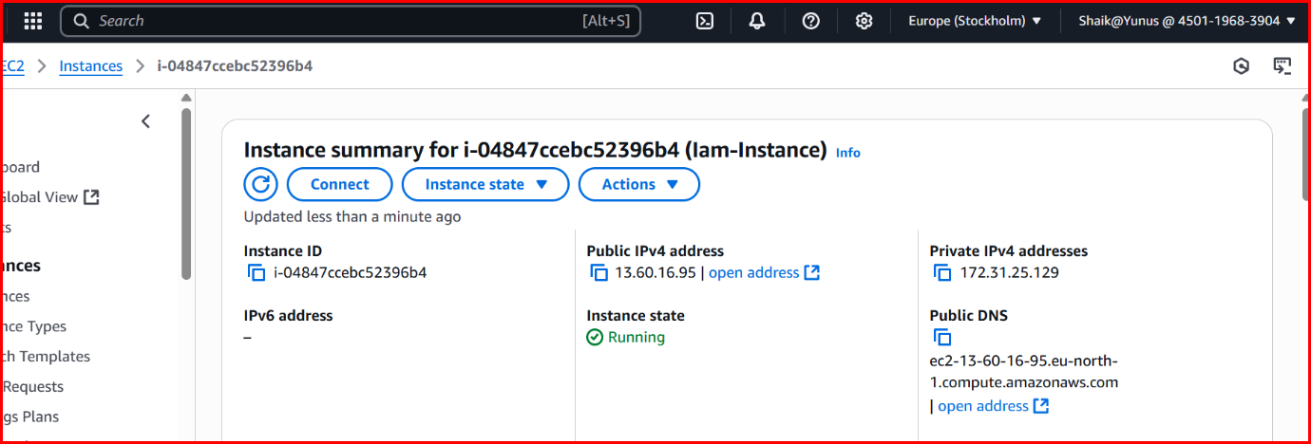

**2.** **Create one Group in IAM and Assign Read access for ec2.**

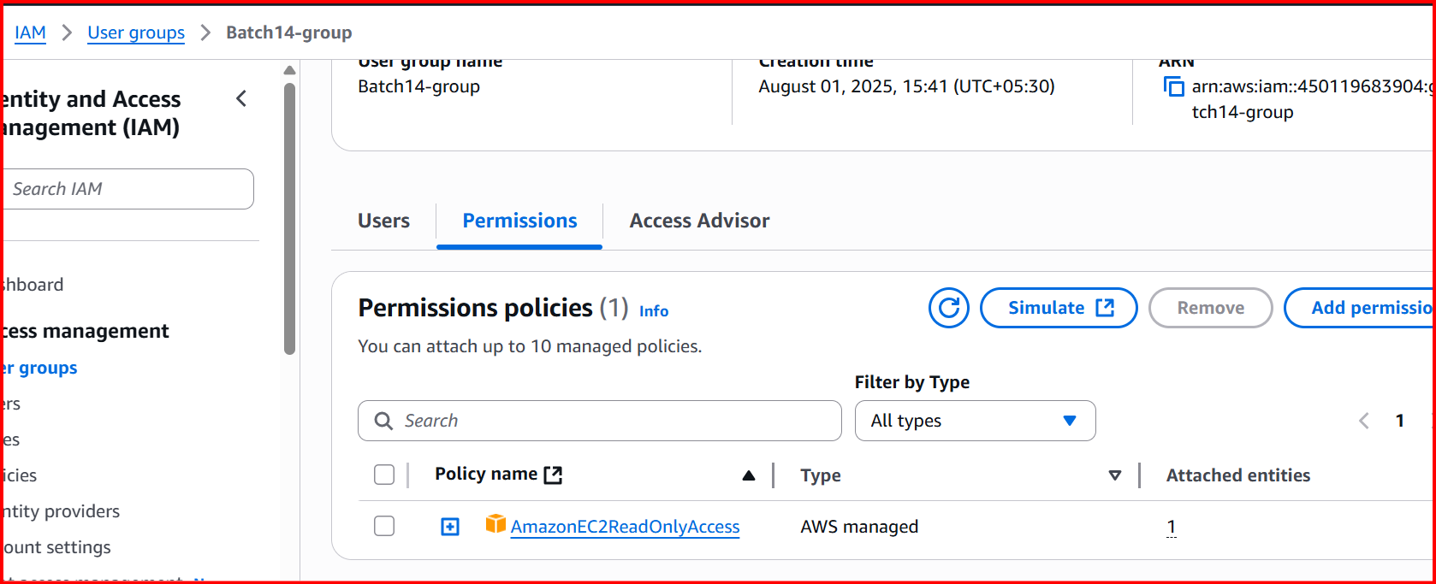

**3.Create a new user with name Devops and add to the group created in task2.**

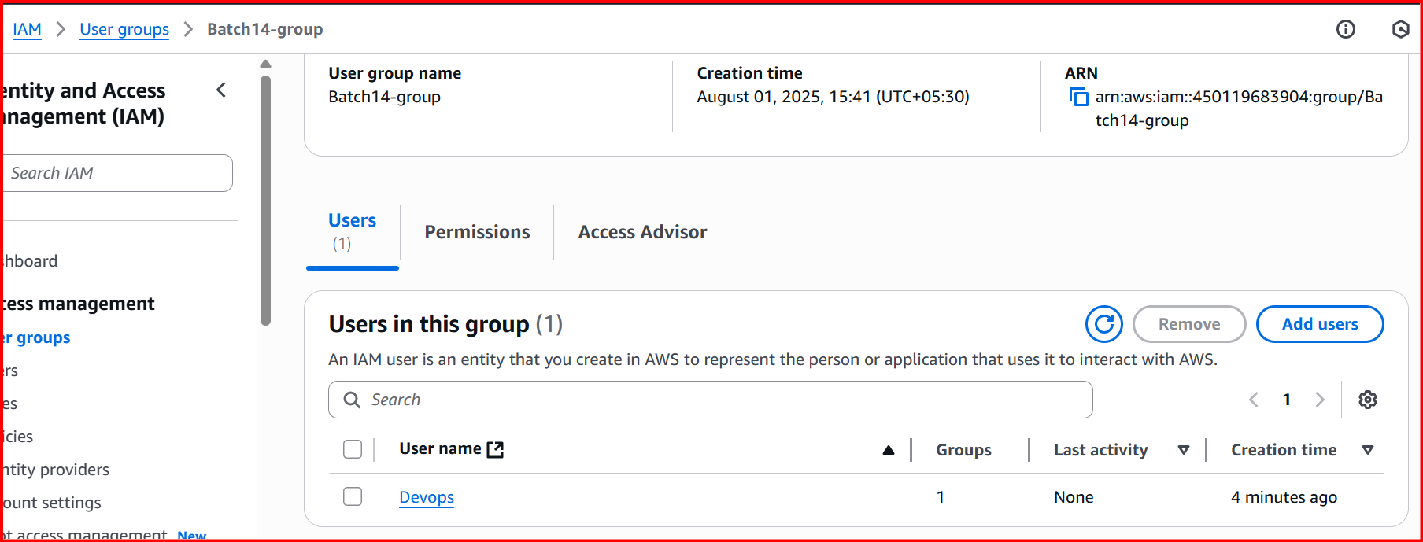

**4. Write a bash script to create a IAM user with VPC full access.**

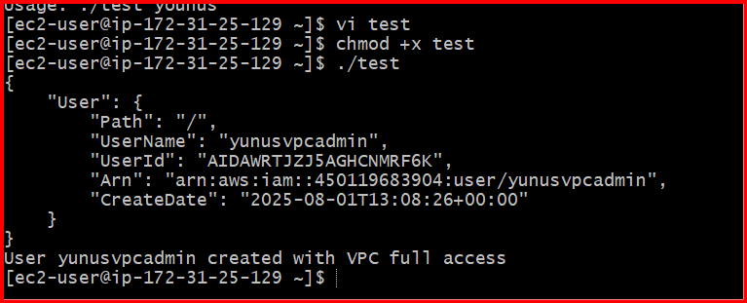

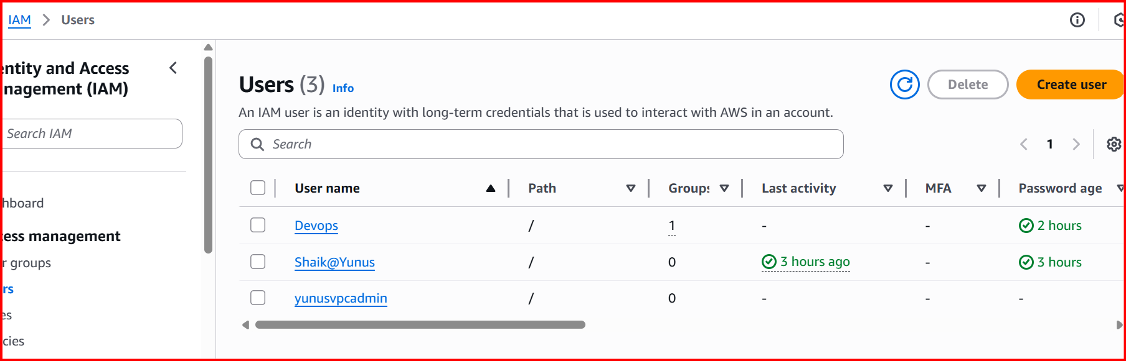

**5. Create a IAM policy to access ec2 for a specific user in specific regions only.**

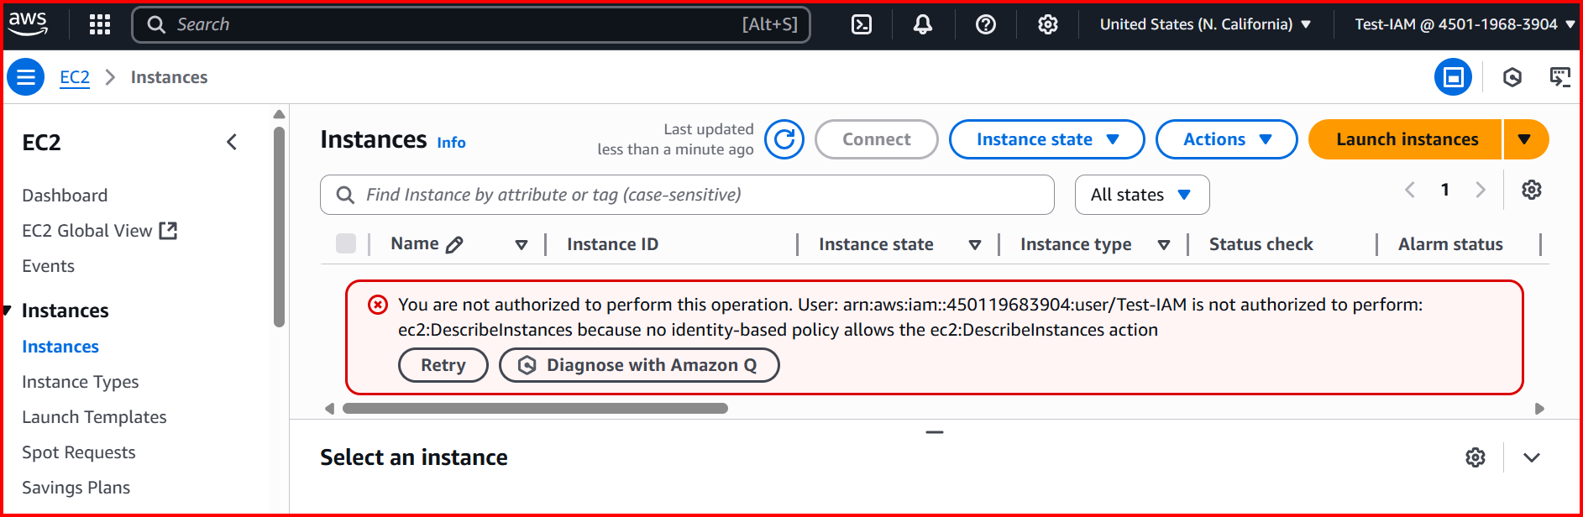

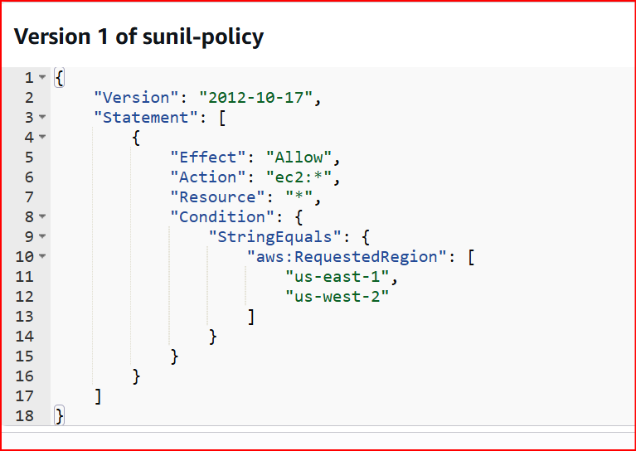

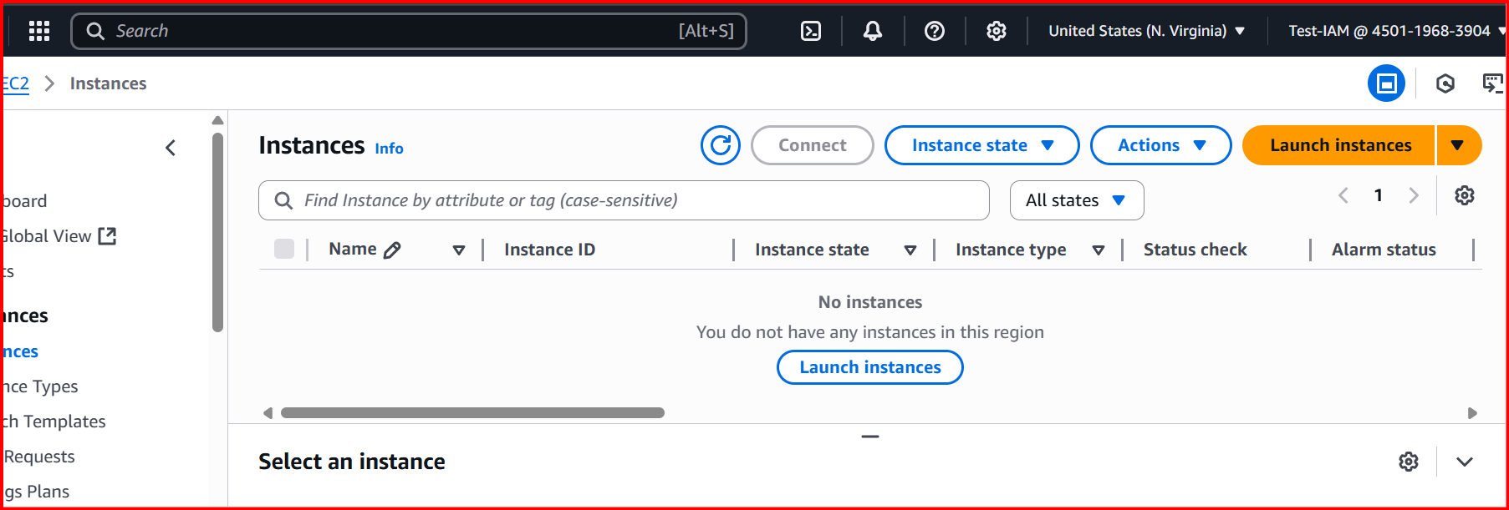

**6.** **We have two accounts Account A and Account B, Account A user should access s3 bucket in Account B.**

**(Collaborate with team member and execute this.Mostly asked in every interview).**

